Tapping the Sun to Clean the Water

Objective  Determine how much clean water can be extracted from muddy water through evaporation.  Materials  Large cooking pot, drinking glass, clear plastic food wrap, masking tape, two  Procedure  Fill the pot to a depth of five centimeters with muddy water. Place the drinking glass right-side-up in the middle of the pot, placing a rock in the glass to keep it from floating, if necessary. Cover the pot with the clear plastic food wrap and tape it firmly to the pot. Place a rock on the plastic wrap to make it sag in the middle, but don't let the plastic wrap touch the glass. Place the pot in direct sunlight for several hours. rocks, muddy water. | 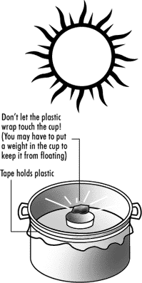
Discussion points
- Why did tiny droplets of water appear on the cool plastic wrap?
- Why did they fall into the drinking glass?
- Is this a good way for your community to get pure drinking water?
- From this experiment, does it look like mud evaporates?
Additional activities
Try this experiment with salty water. Also determine how clean your evaporated water is by placing several drops in a drinking glass and allowing it to evaporate. Do the same with several drops of muddy or salty water. Observe any residue left in the glasses after the clean, muddy or salty water evaporates.
Additional discussion points
Do you get more clean water from salty water or muddy water?

