Understanding Why Coal Burns  Objective  Collect methane gas from coal.  Materials  One-half cup of soft or bituminous coal; hammer; funnel; quart-size glass jar; water; test tube; rubber band.  Procedure  Hammer the coal into a coarse powder. Place your finger in the small end of the funnel and pour the coal into the large end of the funnel, keeping the coal in the funnel with your finger. Turn the jar upside-down, and place it over the funnel. While holding the funnel tight against the bottom of the jar, turn the jar upright and place it on a table. Remove your finger and slowly fill the jar with water until the funnel is completely covered, being careful not to wash the coal out of the funnel. Then fill the test tube with water and place it upside-down over the small end of the funnel, being careful not to let any air into the test tube. Mark the water line on the test tube with the rubber band. Observe the test tube over a two- to three-day period as it fills with methane gas. | 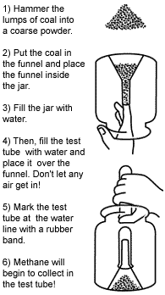
Discussion points
After the tube seems to be filled, will the coal continue to give off methane gas? How can you tell?
Will the methane gas you collected burn? Remove the test tube and put your thumb over the top. Light a match and turn the test tube upright. Holding the match above the test tube, remove your thumb and observe what happens.
What is one reason coal mining can be a dangerous occupation?

